**Bow Shock**

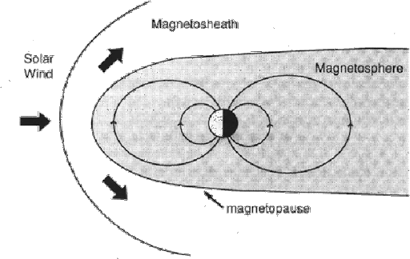

* From the figure it’s understood that Bow shock is point at which solar wind is blocked.
* The region between Magneto pause and bow shock is marked as magnetosheat.
* The defining criterion of a shock wave is that the bulk velocity of the plasma drops from "supersonic" to "subsonic.
* There will be large fluctuation of Magnetic field during Magnetosheath region.
* After magneto pause there will be a stable readings.